Ideation Phase
Brainstorm & Idea Prioritization

Date | 27 JUNE 2025
Team ID | NM2025TMID00401
Project Name | Garage Management System.
Maximum Marks | 4 Marks

Project Overview

This project, titled ‘Garage Management System’, aims to streamline and automate the management of vehicle services, customer records, billing, and mechanic assignments in a garage environment. It provides a centralized system for efficient handling of daily operations, improving accuracy and reducing manual workload.

Step-1: Team Gathering, Collaboration and Problem Selection
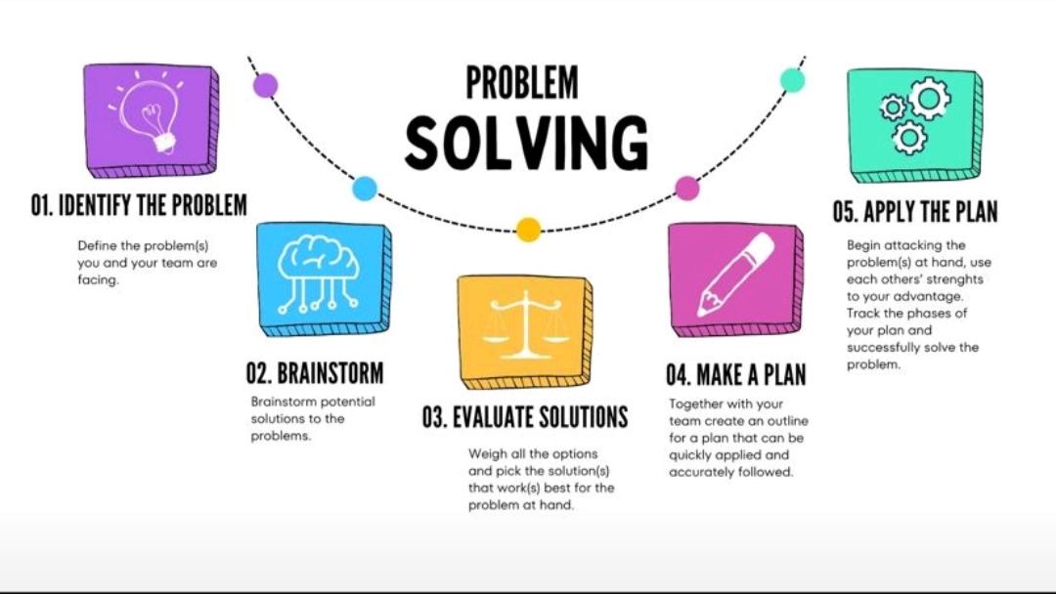

The team collaborated to identify a real-world problem related to manual garage operations and decided to develop a digital Garage Management System. This system will help automate service booking, billing, and maintenance tracking.

Step-2: Brainstorm, Idea Listing and Grouping

Brainstorm:

Team members discussed various features such as vehicle tracking, customer management, inventory control, and service history.

Idea Listing:

Ideas included automated reminders, digital invoices, assigning mechanics to jobs, and tracking garage performance metrics.

Grouping:

The ideas were grouped into core modules like Customer Management, Vehicle Management, Service Management, and Billing.

Action Planning:

Tasks were divided among team members to handle database design, UI development, backend logic, and testing.

Step-3: Idea Prioritization

The team prioritized the ideas based on feasibility and impact. The most critical modules selected were Customer Management, Vehicle Management, and Service Booking. These ensure smooth operation and efficient customer handling.

Step-4: Feature Selection (Chance Fields)

The following fields were identified as essential for the Garage Management System:

- 1. Customer ID, Name, Contact Number, Email

- 2. Vehicle ID, Vehicle Type, Model, Registration Number

- 3. Mechanic ID, Name, Skill Type, Availability

- 4. Service ID, Description, Cost, Duration

- 5. Invoice ID, Payment Method, Total Amount, Date

- 6. Parts Inventory: Part ID, Name, Quantity, Price

- 7. Appointment: Date, Time, Assigned Mechanic, Status

